URGENT PRAYER ALERT: Possible Nuke Attack - Pray the Chaplet
Feb 11, 2018
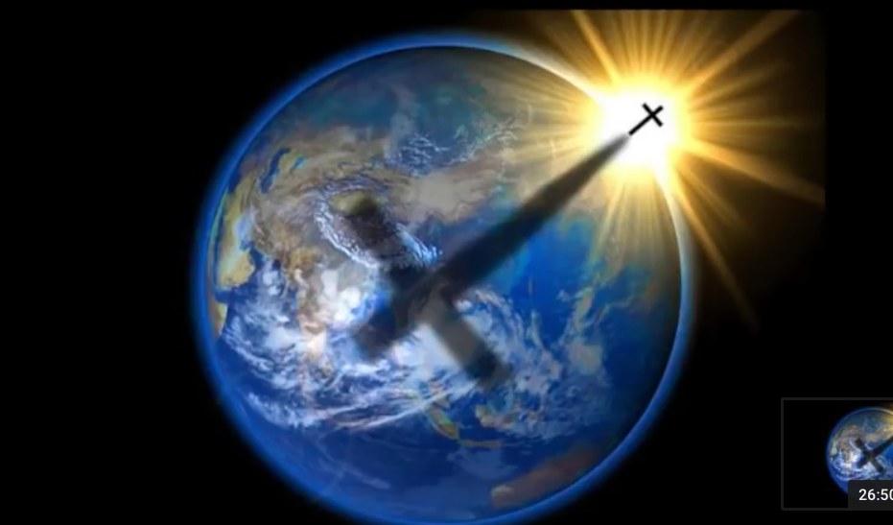
There is another threat of Nuclear War.

Please everyone, begin praying this if you are not, it is so important. I know our version is slow because we really love to enter into the prayer, there are other versions out there that are not contemplative and are about 10 min shorter.

